Title of the project :-

Zero Trust Network Access (ZTNA) with Zscaler: Securing User-to-Application Connectivity.

Overview :-
This project focuses on developing an AI-based identity verification system aimed at enhancing online security by analysing and validating user identities through their behavioural patterns on digital platforms. The system utilizes advanced machine learning techniques to construct detailed user profiles that help distinguish genuine users from potentially suspicious activities. It is designed to address key cybersecurity challenges such as unauthorized access, fraudulent transactions, and other online threats that occur across various digital services and platforms.
The primary goal of this system is to strengthen online security by carefully examining and verifying user identities based on behavioural data. To accomplish this, the system employs advanced technologies such as deep learning, neural networks, and natural language processing to generate dynamic behavioural profiles for each user. These profiles continuously update and adapt according to the user’s actions and interactions over time.
An important capability of the system is real-time anomaly detection, which enables the platform to recognize unusual behaviour that differs from a user’s typical activity pattern. When such deviations are identified, the system can instantly respond to reduce potential security risks. This functionality helps prevent unauthorized access and ensures safer interactions for users across online platforms.
To further enhance the security structure, the system integrates multi-factor authentication mechanisms. Whenever suspicious activity is detected, additional verification steps are activated to confirm the user's identity. Notifications are also sent to both users and administrators, ensuring transparency and enabling quick responses to possible security threats.
Another critical aspect of the system is secure data storage and management. Sensitive data, including behavioural profiles and anomaly detection records, are safeguarded using secure storage methods to maintain user privacy and ensure data integrity.
The system also includes an integration layer that facilitates seamless communication with multiple online platforms and services. Additionally, monitoring and reporting tools are implemented to observe system performance and security status, promoting accountability and operational transparency.
To support a large number of users, the system is designed with scalability and load-balancing features. Security and regulatory compliance are maintained by implementing encryption for data both during transmission and while stored, along with firewalls and intrusion detection systems. The system also adheres to recognized data protection and privacy regulations.
Furthermore, the system can optionally be deployed on cloud infrastructure, which offers improved flexibility and scalability. Continuous training and optimization of the machine learning models help ensure that the system remains effective against emerging cyber threats and evolving user behaviours. Deploying system components across multiple geographic locations can also enhance redundancy, reliability, and overall system performance

List of teammates–
S.no | name | collage | contact
1 | Srinikhil R | Kumaraguru College of Liberal Arts and Science | 7845226710
2 | Subhaharini J | Kumaraguru College of Liberal Arts and Science | 8754888770
3 | Abiram.P | Kumaraguru College of Liberal Arts and Science | 9865949459
4 | Pratheeksha H | Kumaraguru College of Liberal Arts and Science | 8778569956
5 | Adhithya Raghavan S | Kumaraguru College of Liberal Arts and Science | 9442927670

List of Vulnerability Table-

S.no | Vulnerability Name | CWE/CVE - No
1 | Improper Sanitization of File Paths | CWE- 284: Improper Access Control
2 | Invalid Certificate | CWE-395: Improper Certificate Validation
3 | Missing X-Frame-Options Header | CWE-1021: Design Improper Restriction of Rendered UI Layers or Frames
4 | X-Content-Type Options Header Missing | CWE -918: Server-Side Request Forgery (SSRF)
5 | Drupal Ajax API shows JSONP not disabled by default | CWE-937,1035: OWASP Top Ten 2013,2017 Category A9 - Using Components with Known Vulnerabilities
6 | Drupal Api Vulnerability | CWE-20: Improper Input Validation
7 | Improper API Filtration | CWE-79: Improper Neutralisation of Input During Web Page Generation ('Cross-site Scripting')
8 | Denial of Service | CWE -400: Uncontrolled Resource Consumption
9 | TLS Version 1.0 Protocol Detection | CWE-327: Use of a Broken or Risky Cryptographic Algorithm
10 | web.config File Information Disclosure | CWE-497: Exposure of Sensitive System Information to an Unauthorised Control Sphere

Main Website:
S.no | Vulnerability Name | CWE - No
1 | SL Medium Strength Cipher Suites Supported (SWEET32) | CWE-200: Exposure of  Sensitive Information to an Unauthorised Actor
2 | Cookie SERVERID created without secure flag | CWE-79: Improper  Neutralisation of Input During Web Page Generation
3 | X-Content-Type Options Header Missing | CWE-918: Server-Side  Request Forgery (SSRF)
4 | Denial of Service | CWE -400: Uncontrolled  Resource Consumption
5 | OS Identification | CWE-200: Exposure of Sensitive Information to an  Unauthorised Actor

REPORT: -
Practice Website: http://www.itsecgames.com/

Vulnerability Name: Improper Sanitization of File Paths
CWE- 284: Improper Access Control

OWASP Category: A01:2021-Broken Access Control

Description: The product does not restrict or incorrectly restricts access to a resource from an unauthorized actor.
Business Impact: This vulnerability is significant, as it can lead to unauthorized access to sensitive data or files, potentially causing data breaches, privacy violations, and loss of user trust. Affected sites may also require configuration changes after applying a security release.
Steps to Reproduce: https://www.shodan.io/host/31.3.96.40
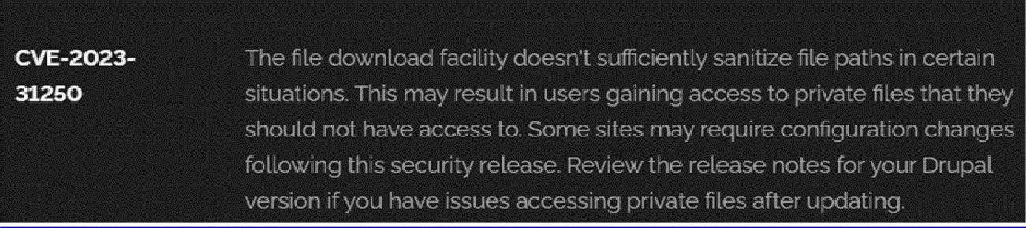

Recommendation:

- Install Security Updates: The first and most important recommendation is to install the security update released by Drupal as soon as it becomes available. These updates usually contain patches that fix known vulnerabilities and protect the system from potential security risks.
- Check Site Configuration: After installing the update, review the configuration settings of your Drupal website to ensure that private files are properly secured. Update file permissions and access settings if necessary to maintain proper protection.
- Perform Regular Security Audits: Conduct periodic security checks and vulnerability assessments to detect and resolve possible security weaknesses within your Drupal site.
- Strengthen Access Control: Apply strict access control measures so that only authorized users can view or manage private files. Regularly review user permissions and limit access wherever possible.
- Limit Sensitive Data Storage: Reduce the amount of sensitive information stored on your Drupal website. Keep only the data that is essential for the system to function effectively.

Vulnerability Name: Invalid Certificate
CWE-395: Improper Certificate Validation

OWASP Category: A07:2021 – Identification and Authentication Failures

Description: When a certificate is invalid or malicious, it might allow an attacker to spoof a trusted entity by interfering in the communication path between the host and client. The product might connect to a malicious host while believing it is a trusted host, or the product might be deceived into accepting spoofed data that appears to originate from a trusted host.
Business Impact: Improper certificate validation can lead to a range of security threats which includes Man-in-the-middle attacks(Attackers can intercept communication between two parties and read or modify the data exchanged between them),Data breaches:(Attackers can gain unauthorized access to sensitive information or sensitive systems, leading to data breaches),Malware distribution(Attackers can use fake digital certificates to distribute malicious software or infect systems with malware)
Steps to Reproduce: https://www.ssllabs.com/ssltest/analyze?d=www.itsecgames.com
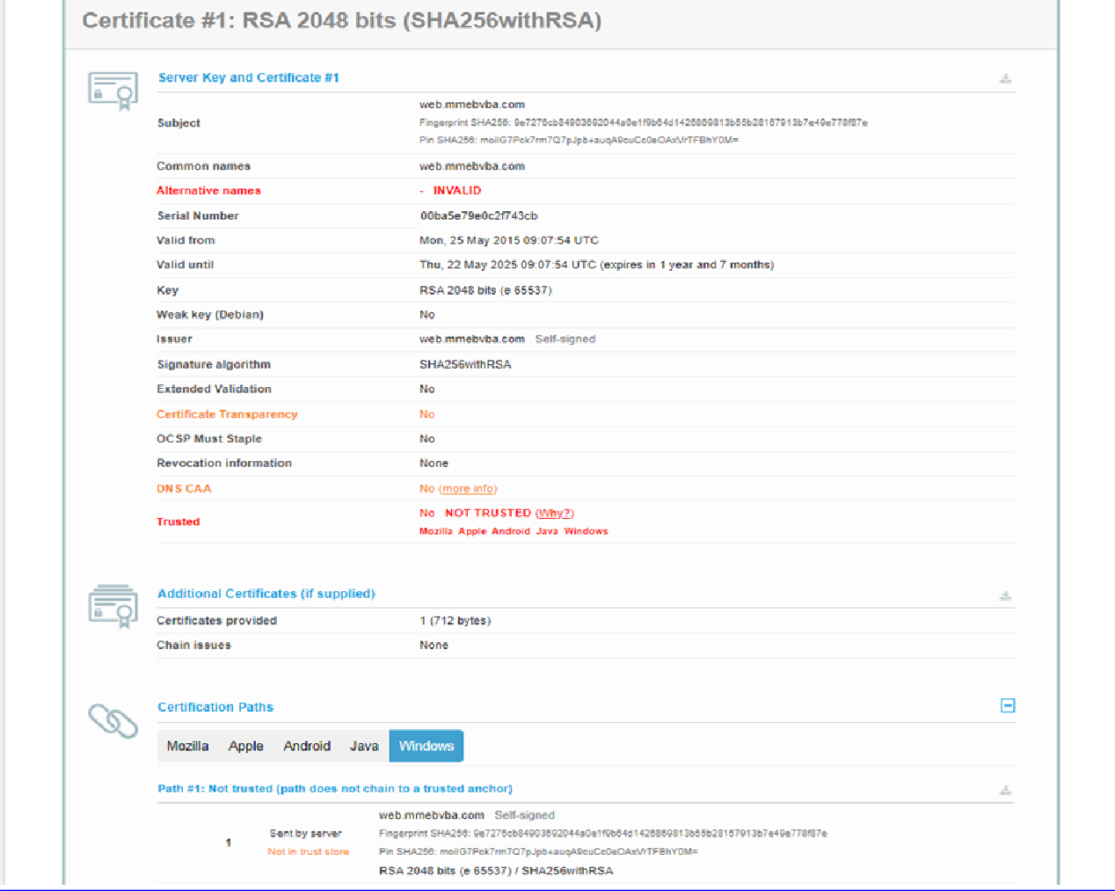

Recommendation:

- Use Reliable Certificate Authorities: Ensure that digital certificates are accepted only from reputable and trusted certificate authorities to maintain secure and authentic communication.

- Validate Certificate Chains: Confirm that the certificate provided by the remote server is valid and issued by a trusted certificate authority. It is also important to verify the complete certificate chain, including any intermediate certificates.

- Check Certificate Revocation: Always verify the revocation status of the certificate to ensure that it has not been cancelled or marked as invalid by the issuing authority.

- Implement Certificate Pinning: Use certificate pinning techniques to guarantee that communication occurs only with the specific certificate or certificate authority that has been approved.

- Update Software Regularly: Keep all software, systems, and security protocols updated since new vulnerabilities are discovered frequently and security patches are released to fix them.

Vulnerability Name: Missing X-Frame-Options Header

CWE-1021: Design Improper Restriction of Rendered UI Layers or Frames

OWASP Category: A04:2021-Insecure Design

Description: A web application is expected to place restrictions on whether it is allowed to be rendered within frames, iframes, objects, embed or applet elements. Without the restrictions, users can be tricked into interacting with the application when they were not intending to.
Business Impact: This enables path to the attackers to manipulate or gain unauthorized access to user interface elements, potentially leading to deceptive or malicious user interactions. This can result in data leakage, fraud, user distrust, and reputational damage, undermining the integrity and trustworthiness of the application and causing financial losses.
Vulnerability Path: http://www.itsecgames.com/

Steps to Reproduce:

- Open the practice website to inspect

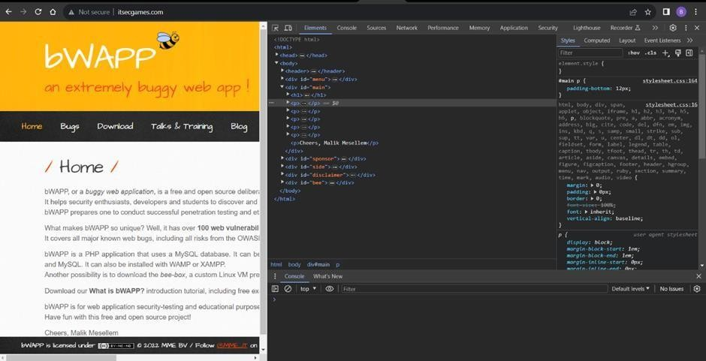

- Go to network and start capturing using F5 or Ctrl+R

- Go to html document and see if x-frame-options present in response headers or not

- If not the absence of this header indicates that the website may not have protection against embedding its content within an iframe on other domains, potentially leaving it vulnerable to clickjacking attacks.
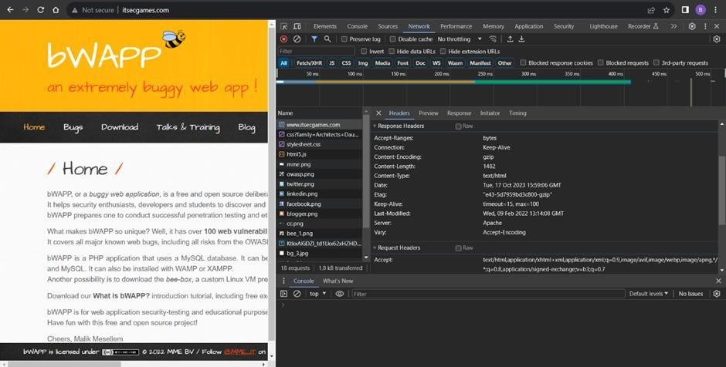

Recommendation:

- Apply Strong UI Access Controls: Implement appropriate access control mechanisms to limit access to user interface layers or frames according to user roles and privileges.
- Use Secure Session and Authentication Management: Ensure strong user authentication and effective session management to prevent unauthorized users from accessing the system.
- Implement Content Security Policy (CSP): Configure CSP headers to control the sources from which resources can be loaded, helping to reduce risks related to frame-based or clickjacking attacks.
- Maintain Updated Software and Libraries: Regularly update all software components and libraries to fix known vulnerabilities and improve overall system security.

- Vulnerability Name: X-Content-Type Options Header Missing CWE -918: Server-Side Request Forgery (SSRF)
OWASP Category: A10:2021 – Server-Side Request Forgery (SSRF)

Description: The web server receives a URL or similar request from an upstream component and retrieves the contents of this URL, but it does not sufficiently ensure that the request is being sent to the expected destination.

Business Impact: The header missing impact Data Exposure(Attackers might force the server to render sensitive data as HTML, leading to data exposure),Security Risks(Content type manipulation can increase security risks, potentially leading to breaches, data leaks, and unauthorized access), Brand and Reputation Damage(Successful attacks that exploit SSRF vulnerabilities can harm the organization's reputation and trustworthiness)
Vulnerability Path : https://securityheaders.com/?q=http%3A%2F%2Fwww.itsecgames.com%2F&followRedirects= on

Steps to Reproduce:

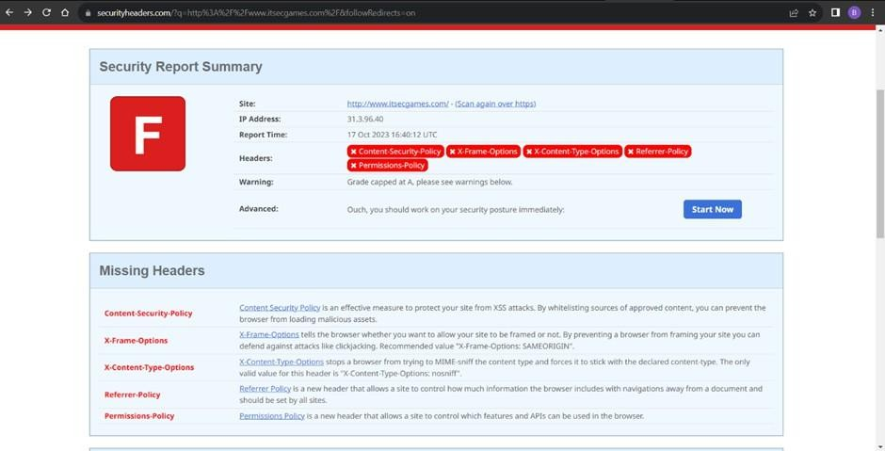
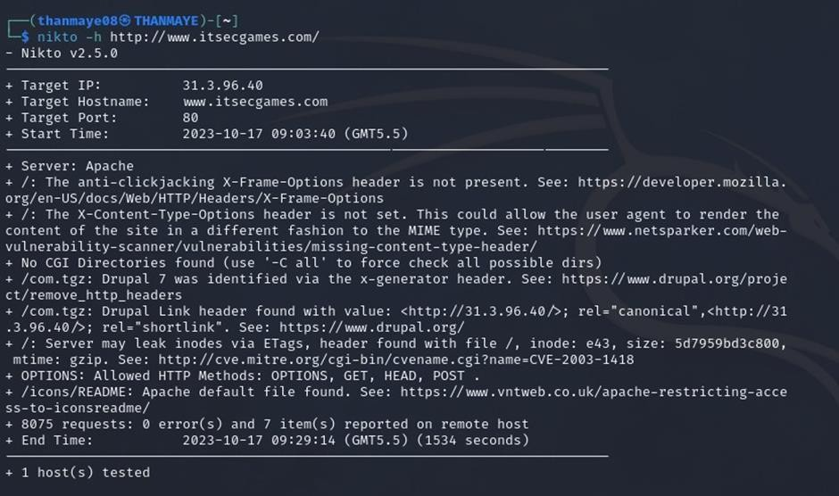
Recommendation:

- Implement "X-Content-Type-Options" Header: Configure the "X-Content-Type-Options" header with the value "nosniff" in your web server or application to prevent content type sniffing.

- Secure SSRF: To directly mitigate SSRF vulnerabilities, ensure proper input validation, access controls, and allow-list-based URL validation to prevent attackers from making unauthorized requests to internal resources.
- Security Headers: Implement other security headers like "X-Frame-Options" and "Content-Security-Policy" to further enhance security and mitigate various types of web-based attacks.
While the "X-Content-Type-Options" header may not be a direct countermeasure to SSRF, it is a valuable security control that, when configured correctly, can help protect against content type- based attacks that may be exploited in SSRF scenarios.

Vulnerability Name: Drupal Ajax API shows JSONP not disabled by default

CWE-937,1035: OWASP Top Ten 2013,2017 Category A9 - Using Components with Known Vulnerabilities
OWASP Category: A06:2021-Vulnerable and Outdated Components

Description: Vulnerable and outdated components refer to using software libraries, modules, or dependencies within a web application that have known security issues or are not updated to the latest secure versions. This can include plugins, frameworks, or APIs that are no longer maintained or have publicly documented vulnerabilities.
Business Impact: The presence of vulnerable and outdated components in a web application poses significant security risks. Attackers can exploit these weaknesses to gain unauthorized access, inject malicious code, steal sensitive data, or disrupt the system's operation. The potential business impacts include compromised user data, damaged reputation, legal consequences, and financial losses due to breach recovery and remediation efforts.
Vulnerability Path: https://www.shodan.io/host/31.3.96.40

Steps to Reproduce:
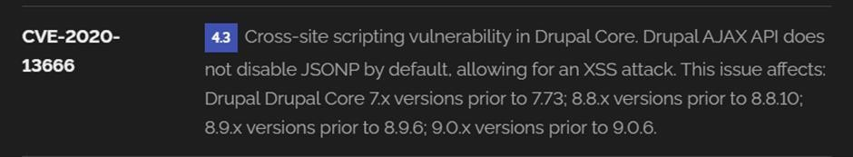

Recommendation:

- Regular Updates: Keep all components, libraries, and dependencies up to date by applying security patches and upgrades.
- Vulnerability Scanning: Conduct periodic vulnerability assessments to identify and address potential issues.
- Dependency Management: Implement a strategy for managing third-party dependencies, including continuous monitoring of their security status.
- Security Testing: Perform regular security testing, including penetration testing and code review, to identify and remediate vulnerabilities.
- Change Control: Maintain a change management process to assess the impact of new components and ensure they don't introduce new vulnerabilities.

- Vulnerability Name: Drupal Api Vulnerability CWE-20: Improper Input Validation
OWASP Category: A03:2021 – Injection

Description: The product receives input or data, but it does not validate or incorrectly validates that the input has the properties that are required to process the data safely and correctly.
Business Impact: The impact of a successful SQL injection attack can be devastating for businesses. It can result in unauthorized access to sensitive information, data theft, financial losses, damage to reputation, and legal consequences. Depending on the nature of the application and data involved, SQL injection can lead to compliance violations, customer trust erosion, and operational disruption.
Vulnerability Path: https://www.shodan.io/host/31.3.96.40

Steps to Reproduce:
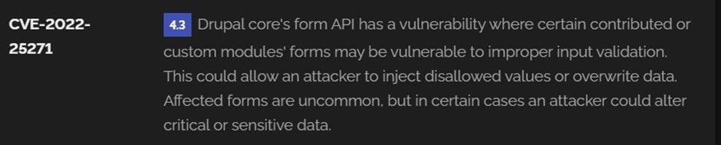

Recommendation:

- Input Validation: Implement rigorous input validation on all user inputs and ensure that only safe, sanitized data is passed to the database.
- Parameterized Queries: Use parameterized queries or prepared statements to separate SQL code from user input, preventing malicious injections.
- Escaping User Input: If parameterized queries are not feasible, escape user input before incorporating it into SQL queries to neutralize special characters.
- Least Privilege Principle: Limit the permissions and access rights of database accounts to the minimum required for specific tasks to minimize the potential damage of an attack.
- Web Application Firewalls (WAF): Employ WAFs to filter and block malicious SQL injection attempts.
- Regular Security Testing: Conduct regular security assessments, including penetration testing, to identify and address vulnerabilities.

Vulnerability Name: Improper API Filtration

CWE-79: Improper Neutralization of Input During Web Page Generation ('Cross-site Scripting')

OWASP Category: A07-2017: Cross-site Scripting (XSS)

Description: The product does not neutralize or incorrectly neutralizes user-controllable input before it is placed in output that is used as a web page that is served to other users.
Business Impact: If exploited, this vulnerability allows attackers to inject malicious scripts into web pages, which can be viewed by other users. The potential business impacts include data theft, unauthorized access, compromised user accounts, damaged reputation, and financial losses. Attackers can use XSS to steal sensitive information, such as user credentials, personal data, or financial details, leading to regulatory compliance violations and legal liabilities. Additionally, defacement or manipulation of website content can erode customer trust and result in lost revenue.
Vulnerability Path: https://www.shodan.io/host/31.3.96.40

Steps to Reproduce:

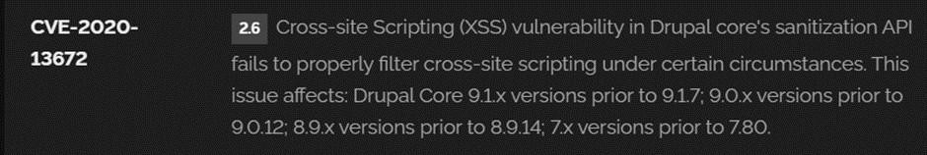

Recommendation:

- Update and Patch: Ensure that Drupal and all related modules and components are up to date with the latest security patches to mitigate known vulnerabilities.
- Input Validation: Implement strong input validation and output encoding to sanitize user inputs and prevent the injection of malicious scripts.
- Content Security Policy (CSP): Implement CSP headers to restrict the sources from which content can be loaded, reducing the risk of XSS.
- Secure Coding Practices: Train developers in secure coding practices, emphasizing the importance of validating and escaping user inputs.
- Security Scanning: Conduct regular security scans and penetration tests to identify and address XSS vulnerabilities.

Vulnerability Name: Denial of Service

CWE -400: Uncontrolled Resource Consumption

OWASP Category:

Description: The Denial of Service (DoS) attack is focused on making a resource (site, application, server) unavailable for the purpose it was designed. There are many ways to make a service unavailable for legitimate users by manipulating network packets, programming, logical, or resources handling vulnerabilities, among others. If a service receives a very large number of requests, it may cease to be available to legitimate users. In the same way, a service may stop if a programming vulnerability is exploited, or the way the service handles resources it uses.
Sometimes the attacker can inject and execute arbitrary code while performing a DoS attack in order to access critical information or execute commands on the server. Denial-of-service attacks significantly degrade the service quality experienced by legitimate users. These attacks introduce large response delays, excessive losses, and service interruptions, resulting in direct impact on availability.

Business Impact: If successfully exploited, it involves overwhelming a system or application with excessive demands on its resources. This can lead to a range of disruptive consequences. The targeted system may experience significant slowdowns, or even complete unresponsiveness, making it difficult or impossible for legitimate users to access. Critical resources like CPU, memory, and network bandwidth can become depleted, causing further degradation in performance. In severe cases, the exploited vulnerability may lead to system crashes or failures, potentially resulting in data loss. This disruption not only impacts business productivity and financial stability but also risks reputational damage, eroding customer trust and confidence.
Additionally, organizations may face regulatory compliance issues if the uncontrolled resource consumption leads to violations of service level agreements or industry standards. Mitigating this vulnerability requires proactive resource management practices and a well-prepared incident response plan to minimize the potential impacts on business operations and customer satisfaction.
Steps to Reproduce: exploit open ports 80 to perform SQL injections, cross-site request forgeries and DDoS attacks.
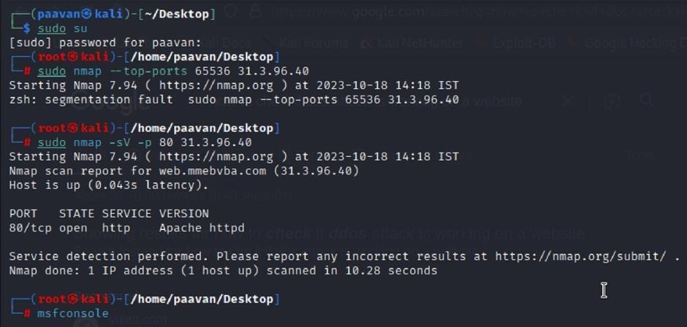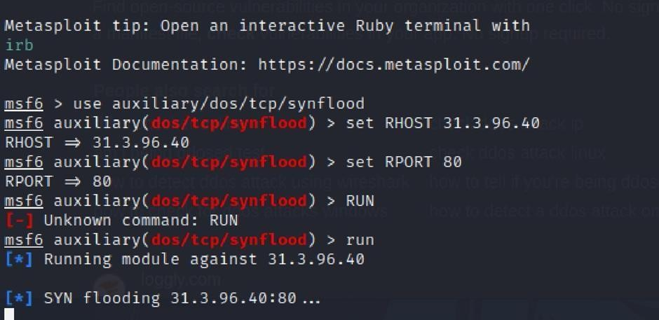

Recommendation: Employ a robust Web Application Firewall (WAF) capable of filtering and mitigating suspicious traffic targeting port 80. Configure it to block excessive requests or patterns indicative of an attack. Utilise load balancing techniques to distribute traffic across multiple servers, ensuring no single server becomes overwhelmed. Additionally, implement rate limiting and throttling mechanisms to restrict the number of requests a single IP address can make within a defined time frame. Regularly monitor traffic patterns and set up alerts to detect unusual spikes in activity, enabling rapid response to potential attacks. Finally, keep software and systems up-to-date with the latest security patches to address known vulnerabilities that attackers may exploit.

- Vulnerability Name: TLS Version 1.0 Protocol Detection CWE-327: Use of a Broken or Risky Cryptographic Algorithm OWASP Category: A02:2021-Cryptographic Failures
Description: The product uses a broken or risky cryptographic algorithm or protocol.

Business Impact: TLS 1.0 is an outdated and vulnerable encryption protocol, and its use can expose sensitive data to potential security threats. This not only jeopardizes the integrity of customer information and payment details but also tarnishes the company's reputation. The business may face legal consequences, loss of customer trust, and decreased revenue as security- conscious users avoid the site due to its security vulnerabilities. Immediate action is necessary to upgrade to a more secure TLS version to safeguard data, ensure compliance, and maintain customer confidence.

Steps to Reproduce:

- Open a terminal or command prompt

- Type the Command: openssl s_client -connect 31.3.96.40:443 -tls1

- The connection is successfully means the server supports TLS 1.0

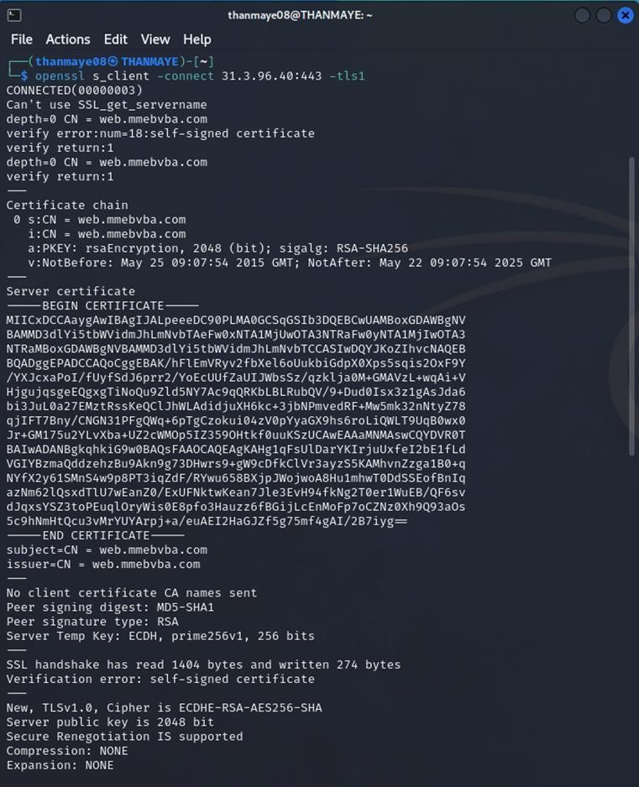

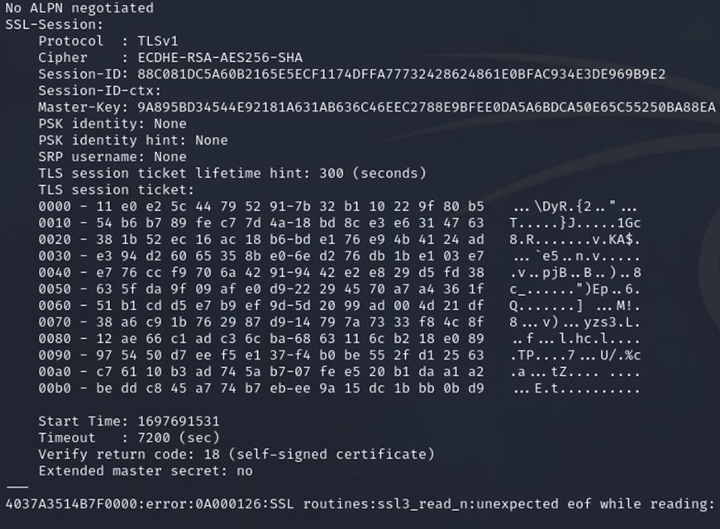

Recommendation:

- Upgrade to a Secure TLS Version: Transition to a more secure TLS version, such as TLS 1.2 or TLS 1.3. This will provide stronger encryption and improved security against modern threats.
- Regularly Update SSL/TLS Configuration: Keep your SSL/TLS configuration up to date to ensure it aligns with the latest security best practices and vulnerabilities.
- Implement a Strong Cryptographic Suite: Use strong cipher suites and secure configurations to further enhance security. Disable weak ciphers and outdated protocols.
- Compliance Checks: Ensure that your website complies with relevant data protection regulations and industry standards (e.g., GDPR, PCI DSS) to avoid legal issues.

Vulnerability Name: web.config File Information Disclosure

CWE-497: Exposure of Sensitive System Information to an Unauthorized Control Sphere

OWASP Category: A3:2017-Sensitive Data Exposure
Description: An information disclosure vulnerability exists in the remote web server due to the disclosure of the web.config file. An unauthenticated, remote attacker can exploit this, via a simple GET request, to disclose potentially sensitive configuration information.
Business Impact: It exposes sensitive configuration details, including database connection strings and encryption keys, to potential attackers. This could lead to unauthorized access, data breaches, and system compromise. The impact includes financial losses, damage to reputation, and legal liabilities as the organization's security and customer trust are compromised.

Steps to Reproduce:
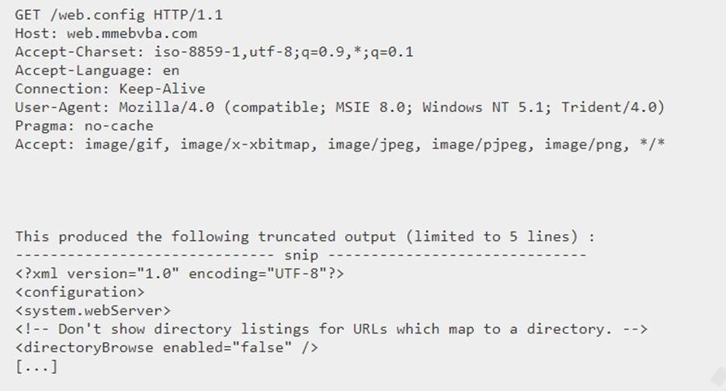

Recommendation:

- Implement proper access controls to restrict access to the web.config file.
- Prevent directory traversal and ensure the web.config file cannot be directly accessed through the web server.
- Encrypt sensitive data within the configuration file.
- Regularly review and update the web.config file, removing any unnecessary sensitive information.
- Ensure that the web.config file is properly secured and not accessible to unauthorized users.

Main Website: vtop.vit.ac.in

- Vulnerability Name: SL Medium Strength Cipher Suites Supported (SWEET32) CWE-200: Exposure of Sensitive Information to an Unauthorised Actor
OWASP Category: Broken access control

Description: The remote host supports the use of SSL ciphers that offer medium strength encryption. Nessus regards medium strength as any encryption that uses key lengths at least 64 bits and less than 112 bits, or else that uses the 3DES encryption suite.
Note that it is considerably easier to circumvent medium strength encryption if the attacker is on the same physical network.
Business Impact:
The vulnerability known as SWEET32 (Short for Sweet 32 Birthday Attack) is associated with the continued use of outdated cryptographic cipher suites that use 64-bit block sizes in TLS and SSL protocols. These cipher suites are vulnerable to birthday attacks, which take advantage of the probability that two encrypted data blocks may collide after a large number of transactions. When an organization’s systems are exposed to SWEET32, encrypted communications may become vulnerable to interception or manipulation by attackers.
Such exploitation could allow unauthorized individuals to access sensitive information, steal confidential data, or even inject malicious code into communication streams. Consequently, this vulnerability poses a serious threat to the confidentiality and integrity of an organization’s data and digital communications.
To resolve this issue, organizations should update their systems to support stronger cipher suites with larger block sizes, which can effectively eliminate the vulnerability and improve the overall security framework. Ignoring the SWEET32 vulnerability may leave organizations exposed to advanced cyberattacks and potential legal or regulatory consequences resulting from data breaches.
Vulnerability Path : The Sweet32 vulnerability when detected with a vulnerability scanner will report it as a CVSS 7.5.

Steps to Reproduce:

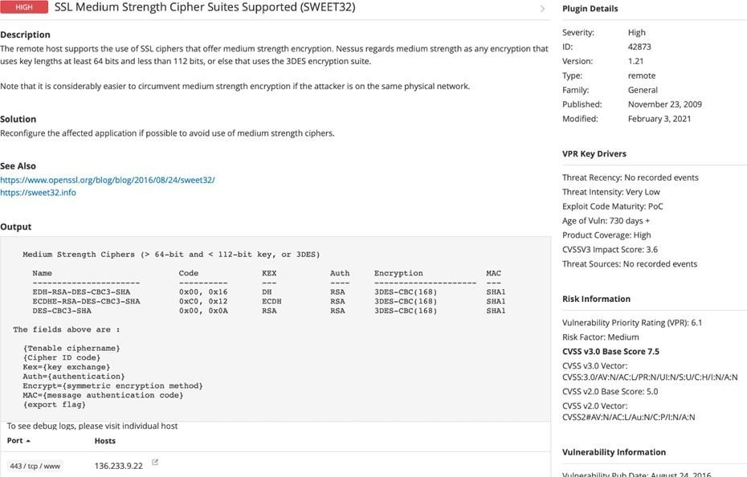
Recommendation: organisations should take several proactive steps. Firstly, it is crucial to update and configure cryptographic libraries, web servers, and any network devices to disable support for cipher suites with 64-bit block sizes. This can be achieved by ensuring that only modern and secure cipher suites are enabled in the TLS/SSL configurations. Additionally, organizations should regularly monitor and assess their systems for any outdated or vulnerable protocols and promptly apply security patches and updates. Implementing strong, unique encryption keys and employing forward secrecy protocols can further bolster security. It's also recommended to utilize intrusion detection systems and perform regular security audits to identify and address any potential vulnerabilities promptly. Lastly, organizations should stay informed about emerging security threats and best practices in cryptographic protocols to proactively adapt their security measures. By taking these measures, businesses can significantly reduce the risk of falling victim to SWEET32 attacks and enhance the overall security of their digital infrastructure.

- Vulnerability Name: Cookie SERVERID created without secue flag CWE-79: Improper Neutralization of Input During Web Page Generation OWASP Category: A07-2017: Cross-site Scripting

Description: The vulnerability allows an attacker to inject malicious code into a WordPress website, which can then be executed by visitors to the website.
To exploit this vulnerability, an attacker would simply need to trick a user into clicking on a malicious link or opening a malicious attachment. Once the user clicks on the link or opens the attachment, the attacker's code would be executed, giving the attacker control over the user's account and potentially the entire WordPress website.
Business Impact: The business consequences of XSS can be severe, ranging from reputational damage due to compromised customer trust, to legal repercussions in cases of data breaches.
Moreover, it can lead to financial losses through fraud or the cost of remediation efforts. Beyond the immediate impacts, long-term harm may occur if customers abandon the platform due to security concerns. To mitigate CWE-79, businesses must implement rigorous input validation and output encoding practices, as well as stay vigilant for emerging threats in web application security. Failure to address XSS vulnerabilities could result in significant harm to both the business's reputation and its bottom line.
Vulnerability Path: https://securityheaders.com/

q=http%3A%2F%2Fvtop.vit.ac.in%2F&followRedirects=on

Steps to Reproduce:
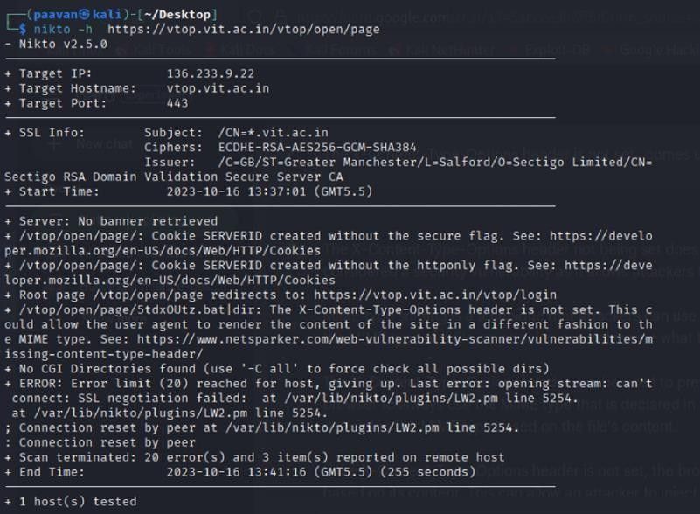

Recommendation:

- Update and Patch: Ensure that Drupal and all related modules and components are up to date with the latest security patches to mitigate known vulnerabilities.
- Input Validation: Implement strong input validation and output encoding to sanitize user inputs and prevent the injection of malicious scripts.
- Content Security Policy (CSP): Implement CSP headers to restrict the sources from which content can be loaded, reducing the risk of XSS.
- Secure Coding Practices: Train developers in secure coding practices, emphasizing the importance of validating and escaping user inputs.
- Security Scanning: Conduct regular security scans and penetration tests to identify and address XSS vulnerabilities.

- Vulnerability Name: X-Content-Type Options Header Missing CWE-918: Server-Side Request Forgery (SSRF)
OWASP Category: A10:2021 – Server-Side Request Forgery (SSRF)

Description: The absence of the "X-Content-Type-Options" header poses a notable security risk for web applications. This header is a crucial security feature that instructs the browser to interpret files with a MIME type as declared in the Content-Type header, rather than trying to guess the type. When this header is missing, the browser may attempt to infer the content type, leaving room for potential misinterpretation and security vulnerabilities like MIME-sniffing attacks. This could enable attackers to disguise malicious content, such as scripts or executable files, as benign content, leading to Cross-Site Scripting (XSS) or other types of attacks.
Implementing the "X-Content-Type-Options" header with the value "nosniff" is a fundamental security measure that helps prevent these risks. It ensures that browsers strictly adhere to the declared content type, enhancing the overall security posture of the web application and safeguarding against potential exploitation stemming from content misinterpretation.
Business Impact: The header missing impact Data Exposure(Attackers might force the server to render sensitive data as HTML, leading to data exposure),Security Risks(Content type manipulation can increase security risks, potentially leading to breaches, data leaks, and unauthorized access), Brand and Reputation Damage(Successful attacks that exploit SSRF vulnerabilities can harm the organization's reputation and trustworthiness)

Vulnerability Path :
https://securityheaders.com/?q=http%3A%2F%2Fvtop.vit.ac.in%2F&followRedirects=on

Steps to Reproduce:

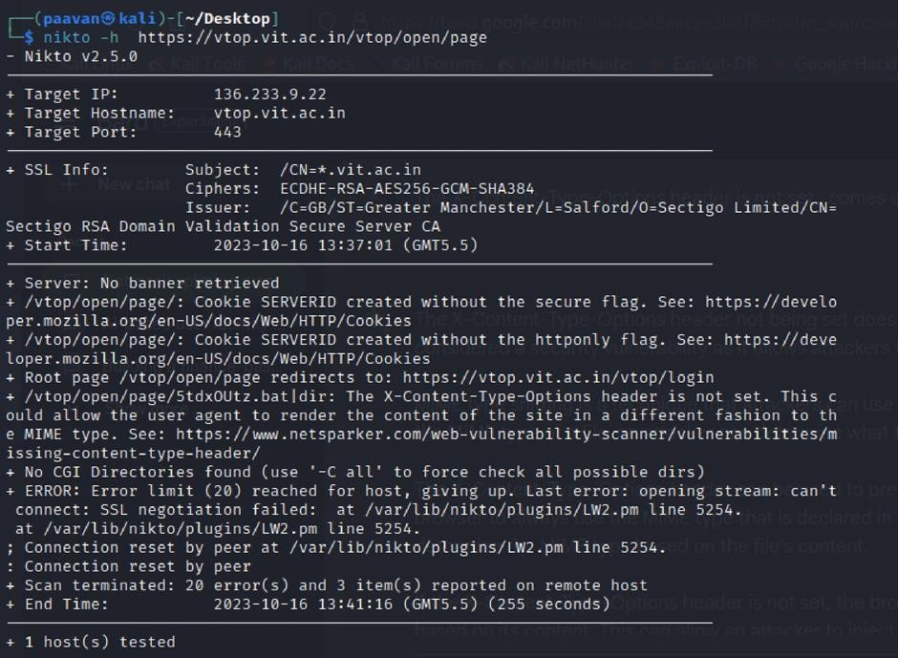

Recommendation:

- Implement "X-Content-Type-Options" Header: Configure the "X-Content-Type-Options" header with the value "nosniff" in your web server or application to prevent content type sniffing.
- Secure SSRF: To directly mitigate SSRF vulnerabilities, ensure proper input validation, access controls, and allow-list-based URL validation to prevent attackers from making unauthorized requests to internal resources.
- Security Headers: Implement other security headers like "X-Frame-Options" and "Content-Security-Policy" to further enhance security and mitigate various types of web-based attacks.
While the "X-Content-Type-Options" header may not be a direct countermeasure to SSRF, it is a valuable security control that, when configured correctly, can help protect against content type- based attacks that may be exploited in SSRF scenarios.

Vulnerability Name: Denial of Service

CWE - 400: Uncontrolled Resource Consumption

Description: The Denial of Service (DoS) attack is focused on making a resource (site, application, server) unavailable for the purpose it was designed. There are many ways to make a service unavailable for legitimate users by manipulating network packets, programming, logical, or resources handling vulnerabilities, among others. If a service receives a very large number of requests, it may cease to be available to legitimate users. In the same way, a service may stop if a programming vulnerability is exploited, or the way the service handles resources it uses.
Sometimes the attacker can inject and execute arbitrary code while performing a DoS attack in order to access critical information or execute commands on the server. Denial-of-service attacks significantly degrade the service quality experienced by legitimate users. These attacks introduce large response delays, excessive losses, and service interruptions, resulting in direct impact on availability.
Business Impact:
If this vulnerability is successfully exploited, it can overwhelm a system or application by placing excessive demands on its resources. This may result in several disruptive effects. The affected system could experience severe slowdowns or become completely unresponsive, making it difficult or impossible for legitimate users to access the service. Essential resources such as CPU, memory, and network bandwidth may become exhausted, further reducing system performance.
In more serious situations, the vulnerability could cause system crashes or operational failures, which may even lead to potential data loss. Such disruptions can negatively affect business productivity and financial stability, while also damaging the organization’s reputation and reducing customer trust and confidence.
Furthermore, organizations may encounter regulatory or compliance issues if excessive resource usage leads to violations of service level agreements or established industry standards. To reduce these risks, organizations should adopt proactive resource management strategies and maintain a well-structured incident response plan. These measures can help minimize the impact on business operations and ensure better service reliability and customer satisfaction.
Steps to Reproduce: exploit open ports 443 to perform SQL injections, cross-site request forgeries and DDoS attacks.

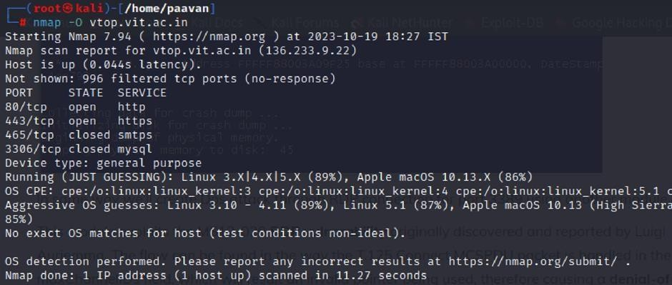
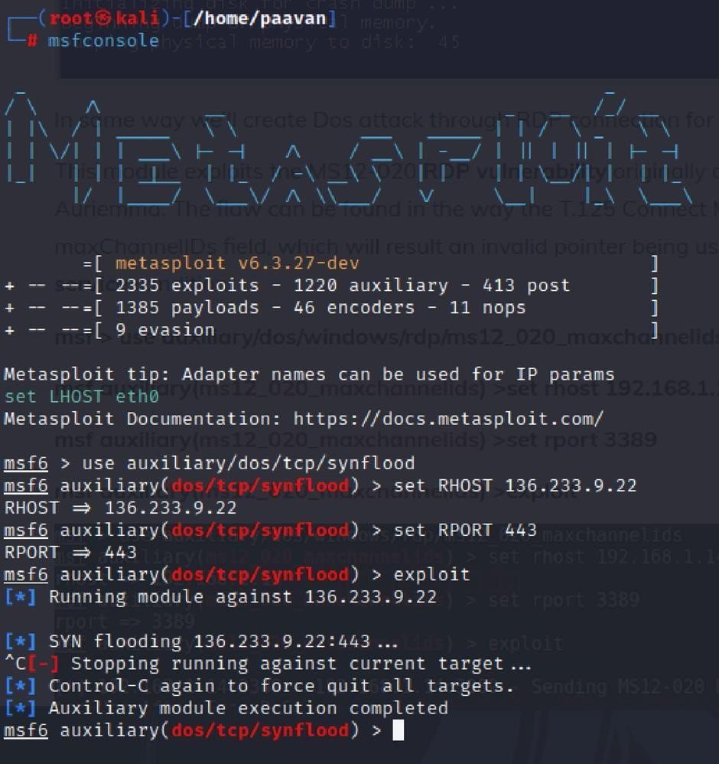

Recommendation: employ a robust Web Application Firewall (WAF) capable of filtering and mitigating suspicious traffic targeting port 80. Configure it to block excessive requests or patterns indicative of an attack. Utilise load balancing techniques to distribute traffic across multiple servers, ensuring no single server becomes overwhelmed. Additionally, implement rate limiting and throttling mechanisms to restrict the number of requests a single IP address can make within a defined time frame. Regularly monitor traffic patterns and set up alerts to detect unusual spikes in activity, enabling rapid response to potential attacks. Finally, keep software and systems up-to-date with the latest security patches to address known vulnerabilities that attackers may exploit.

Vulnerability Name: OS Identification

CWE-200: Exposure of Sensitive Information to an Unauthorised Actor

OWASP Category: A02:2021-Cryptographic Failures

Description: Using a combination of remote probes (e.g., TCP/IP, SMB, HTTP, NTP, SNMP, etc.), it is possible to guess the name of the remote operating system in use. It is also possible sometimes to guess the version of the operating system.
Business Impact: If sensitive information is improperly handled or inadequately protected, it can lead to financial losses, regulatory penalties, and damage to reputation. Customers may lose trust in the organization's ability to safeguard their data, potentially resulting in a loss of business and market share. Legal consequences and compliance issues may arise, leading to additional costs. Moreover, intellectual property theft or exposure can compromise a company's competitive edge. Remediation efforts, including implementing stronger security measures and compensating affected parties, can also entail substantial expenses. Overall, CWE-200 highlights the critical importance of robust data protection measures to safeguard an organization's financial health, reputation, and long-term viability.
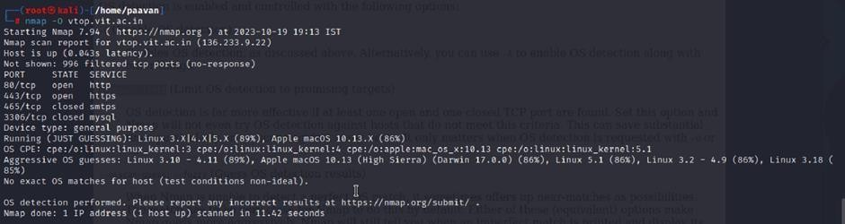
Steps to Reproduce: use nmap -O TARGET to enable os detection

Recommendation:
It is recommended to implement strong encryption protocols to protect data both during transmission and while stored. This should be combined with strict access control policies and robust authentication mechanisms to ensure that only authorized individuals can access sensitive information. Regular vulnerability assessments and penetration testing should also be carried out to detect and fix potential security weaknesses within the system.

Providing employees with proper security awareness training is equally important. Such training should focus on safe data handling practices and help employees recognize possible security threats. In addition, using data masking techniques in non-production environments and implementing advanced Data Loss Prevention (DLP) solutions can further strengthen security measures.

Organizations should also ensure compliance with applicable data protection laws and regulatory requirements. Establishing a clear and effective incident response plan is another important step in creating a strong strategy to protect against the exposure of sensitive information.

This stage represents the first phase in web application security testing, where guidance is often taken from the OWASP Top 10 framework. The OWASP Top 10 is a well-known list that highlights the most critical security risks affecting web applications. Understanding these risks plays an important role in improving the security and reliability of web-based systems.

